BAYESIAN UNCERTAINTY-AWARE LANDSLIDE SUSCEPTIBILITY MAPPING: APPLICATION TO CHATTOGRAM, BANGLADESH

Golam Murad¹, Shotabdy Chowdhury Srabony², Shafiq Mahmud³, Md. Aftabur Rahman^{4*}, Hideaki Yasuharara⁵
¹Graduate, Department of Civil Engineering, Chittagong University of Engineering & Technology, Chattogram-4349, Bangladesh, Email: u1901087@student.cuet.ac.bd
²Research Assistant, Department of Civil Engineering, Chittagong University of Engineering & Technology, Chattogram-4349, Bangladesh, Email: u1901052@student.cuet.ac.bd
³Undergraduate Student, Department of Urban and Regional Planning, Chittagong University of Engineering & Technology, Chattogram-4349, Bangladesh, Email: u2105051@student.cuet.ac.bd
⁴Professor, Department of Civil Engineering, Chittagong University of Engineering & Technology, Chattogram-4349, Bangladesh, Email: maftabur@cuet.ac.bd
⁵Professor, Department of Urban Management, Kyoto University, Japan, Email: yasuhara.hideaki.7pkyoto-u.ac.jp

*Corresponding Author: Md. Aftabur Rahman

Abstract
Landslide-prone hilly regions experiencing rapid urban expansion need susceptibility models that provide both robust predictive performance and transparent uncertainty estimates. This study develops an uncertainty-aware probabilistic framework for landslide susceptibility mapping in the Chattogram metropolitan hill system of Bangladesh, incorporating 14 conditioning factors: geomorphological, hydrological, environmental, and anthropogenic. Multicollinearity analysis, i.e., VIF and tolerance, verified the statistical stability of the predictors. Four classifiers have been compared: Bayesian Logistic Regression, Gaussian Process Classifier, L2-regularized Logistic Regression, and Random Forest, within a standardized preprocessing pipeline. Models have been evaluated using cross-validation, holdout testing, and spatial block validation, with metrics for discrimination, robustness, and calibration. Although Random Forest achieved the strongest discrimination (ROC-AUC = 0.866; MCC = 0.611) on the holdout set, the Gaussian Process Classifier showed better probability calibration (ECE = 0.084) and competitive discrimination (ROC-AUC = 0.821) among all models; hence, it is considered for this research. Susceptibility and uncertainty have been combined in a 3×3 scheme to visualize hazard and confidence. The mapping showed that 78.71% of landslides fell into the Very High class, covering only 9.47% of the area (SCAI = 0.12). These results show that uncertainty-aware Bayesian modeling with bivariate spatial integration enhances interpretability and provides transparent hazard assessments in data-limited urban hill areas.

Keywords: Landslide susceptibility; Bayesian inference; Gaussian processes; Uncertainty quantification; SCAI.

Introduction

Landslides are complex geohazards that result from interactions among geological, lithological, hydrological, and human factors (Azad et al. 2025). They cause significant loss of human life and damage to infrastructure in mountains and hilly areas worldwide (Rahman and Konagai 2018). Due to rapid land-use change and heavy rainfall, landslide impact is becoming more significant (Rahman and Konagai 2017). Landslides are among the most frequent lithosphere hazards, and their occurrence in Bangladesh has been increasing for the last 20 years (Hafsa et al. 2022). Therefore, spatially explicit landslide susceptibility maps (LSMs) serve as targeted tools for land use planning, early warning systems, and disaster risk reduction (Chowdhury et al. 2023).

The predictive ability of LSMs has been greatly enhanced by recent developments in remote sensing, geographic information systems (GIS), and machine learning (Huang et al. 2024). However, there are still two methodological challenges. First, despite having high predictive accuracy, models often fail to generalize spatially, especially when evaluation relies on naïve random cross-validation that does not account for spatial autocorrelation (Adnan et al. 2020; Koldasbayeva et al. 2024). Second, many models provide only deterministic point predictions without uncertainty estimates, which makes them less useful for decision-making under risk (Milà et al. 2024).

Common machine learning algorithms like Random Forest and Support Vector Machines tend to maximize classification accuracy. However, they do not, by default, offer well-calibrated probabilistic outputs or explicit uncertainty quantification (Shaker and Hüllermeier 2025). As a result, predictions may appear overconfident when transferred to novel terrain conditions. On the other hand, the Bayesian approach treats model parameters as probability distributions rather than fixed values. This allows for the formal propagation of epistemic uncertainty into posterior predictive distributions (Mirus and Woodard 2023). Such models are well-suited for risk management, as they not only yield high predicted risks but also explicit statements of the confidence in those predictions (Stefanini et al. 2025).

In Bangladesh, the Chittagong Hill Tracts and metropolitan areas are settings where improved LSM practices are urgently needed. This region is highly susceptible to landslides for several reasons, such as steep slopes, intense monsoon rainfall, and escalating human encroachment (Biswas et al. 2026). During the monsoon, the frequency of landslides becomes a significant threat in this area, which eventually causes fatalities and socio-economic losses (Biswas et al. 2026). Traditional GIS methods, logistic regression, decision tree variants, ensemble tree-based models, and some deep learning models have shown strong performance in discriminating landslide susceptibility in regional susceptibility studies (Murad and Rahman 2025). However, a considerable number of these studies lack proper spatial data resolution, lack spatial validation, and sufficient uncertainty quantification. Addressing these shortcomings is essential for effective disaster risk reduction in such a dynamic environment (Cruz et al. 2024).

Recent research efforts on data-driven LSMs have evolved towards two main pathways. The former focuses on optimizing algorithmic performance metrics, such as the area under the receiver operating characteristic curve (AUC) and accuracy when using ensemble strategies, while the latter combines evaluation data with generation data (Zhou and Xing 2025). The hybrid and stacked models usually perform better than single learners. These models are also fairly complex, making them less explainable (Rukh et al. 2024). The second direction, which emphasizes a methodological domain in its evaluation for LSMs (spatial validation, probabilistic calibration, and uncertainty quantification) as essential elements of any robust model (Vashisht et al. 2026).

Bayesian machine learning addresses these limitations in a coherent manner. Bayesian logistic regression and Gaussian process classifiers are machine learning algorithms that provide posterior predictive distributions rather than point estimates (Carleton et al. 2023). This ability is especially advantageous in hilly urban settings, where significant epistemic uncertainty accompanies assessments of landslide susceptibility in data-poor contexts due to diverse and overlapping conditioning factors (Chowdhury et al. 2023). In addition, mitigation actions such as the reinforcement of slopes, improvement of drainage, or even relocation need to be informed not only by where landslides are likely to happen but also by how confident we are in these predictions (Pareek et al. 2024).

Addressing these methodological and practical gaps, this study proposes a reproducible, uncertainty-aware modeling framework for LSM on urban hillslopes in regions such as Chattogram, Bangladesh. The framework incorporates spatial validation, probabilistic calibration assessment, and uncertainty quantification. Performance estimates (statistically robust and spatially realistic) were compared under repeated stratified cross-validation, spatial block cross-validation, and independent holdout testing for both deterministic and Bayesian classifiers. Model evaluation goes beyond measures of discrimination to include calibration metrics that assess how predicted probabilities relate to observed landslide occurrence rates. Although several algorithms are benchmarked under identical conditions, final deployment is limited to Bayesian classifiers that generate posterior predictive distributions and associated uncertainty surfaces.This study contributes to improving LSM practice for evidence-based intervention planning in data-scarce urban hill regions by integrating predictive accuracy, robust spatial validation, probabilistic classification, and explicit uncertainty representation.

Study Area
The study area is situated in the Chattogram Metropolitan Area (CMA), Bangladesh. CMA is located roughly between (22°06′N–22°34′N) latitude and (91°40′E–92°02′E) longitude, covering an area of about 775 km² (Chowdhury et al. 2023). Within CMA, the study area covers a spatially continuous terrain covering Fatehpur Union and parts of several wards under Chattogram City Corporation (CCC) jurisdiction, as well as adjacent administrative areas associated with Bayezid Bostami, Khulshi, Kotwali, and Panchlaish thanas (Ahmed 2014).
The studied region is characterized by a typical geomorphological feature of the Chattogram metropolitan hill system, an amalgamated topography composed of varied elevations, moderate to steep slopes separated from each other by low-lying plains (Islam et al. 2021). Elevation can change significantly over short spatial distances, leading to localized areas of slope instability (Song et al. 2023). Natural relief has been modified due to rapid urban growth, hill cutting, road construction, and changing land use, which has increased landslide susceptibility (Hen-Jones et al. 2025).
Regarding climatic conditions, the region falls in a tropical monsoon zone with high seasonal rainfall during the monsoon period (June–September) (Stacey et al. 2023). Heavy continuous rain increases soil moisture, decreases shear strength, and raises the risk of landslides (Biswas et al. 2026). The area studied was selected due to the documented occurrence of landslides, heterogeneous terrain, and pressures from urban infrastructure and building construction development. These attributes render it an ideal case for probabilistic landslide-susceptibility modeling and subsequent infrastructure-vulnerability assessment, employing geospatial and Bayesian machine-learning techniques. The location map is shown in Figure 1.

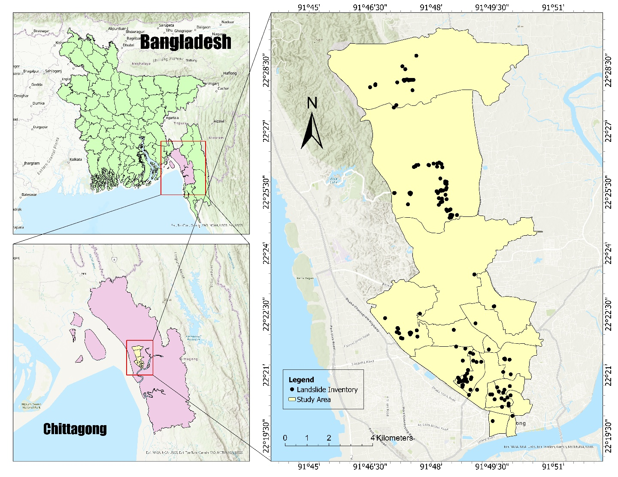
Figure 1: Study Area with Landslide Inventory Points

Landslide Inventory & Conditioning Factors
The landslide inventory map is the primary step of this research. The historical landslide locations were collected from several credible datasets, such as NASA’s global landslide catalogue dataset, the Center for Environmental and Geographic Information Services (CEGIS), the Bangladesh Army, and some related literature records (Rabby and Li 2019). Overall, 155 validated landslide points from 2001 to 2022 were identified in the study area, spanning a range of topographical and geomorphological conditions. These sites were treated as point features in a GIS environment to create an overall landslide inventory map for susceptibility modeling. The landslide points are marked in Figure 1. In addition to those recorded at the landslide points, around 200 non-landslide alternatives were randomly synthesized from stable places devoid of any historical landslide incidents (Xia et al. 2023).
Based on literature review and data availability, fourteen conditioning factors representing topographic (slope, aspect, elevation), hydrological (drainage density), environmental (land use/land cover), proximity (distance to road, distance to river), and soil-related factors were selected, as given in Table-1. All raster layers were resampled to a consistent 30-m spatial resolution for data analysis (Adnan et al. 2020). Topographic derivatives, including slope, aspect, curvature, SPI, TWI, and TRI, were extracted from the 30 m SRTM DEM (Murad et al. 2025). Hydrological and proximity-related variables were generated from DEM-based drainage networks and OpenStreetMap road data (Tai et al. 2020). Vegetation and land cover information were derived from Landsat 8 Level-2 surface reflectance imagery (NDVI) and Esri Sentinel-2 Land Cover data (10 m, resampled to 30 m) (Arrogante-Funes et al. 2024a). Precipitation data were obtained from the CHIRPS dataset (5 km resolution), and soil texture data were sourced from the ISRIC SoilGrids (250 m resolution) (Cunha et al. 2018). Categorical variables (aspect, LULC, and soil texture) were transformed using one-hot encoding to avoid artificial ordinality in machine learning models (Hengl et al. 2017).

Table 1: Landslide Conditioning Factors
Factor | Source of Data | Spatial Resolution (m)
Elevation | https://earthexplorer.usgs.gov/  SRTM DEM | 30 m × 30 m
Slope | https://earthexplorer.usgs.gov/  Derived from SRTM DEM | 30 m × 30 m
Aspect | https://earthexplorer.usgs.gov/  Derived from SRTM DEM | 30 m × 30 m
Curvature | https://earthexplorer.usgs.gov/  Derived from SRTM DEM | 30 m × 30 m
SPI | https://earthexplorer.usgs.gov/  Derived from SRTM DEM | 30 m × 30 m
TWI | https://earthexplorer.usgs.gov/  Derived from SRTM DEM | 30 m × 30 m
TRI | https://earthexplorer.usgs.gov/  Derived from SRTM DEM | 30 m × 30 m
NDVI | https://earthexplorer.usgs.gov/  Landsat 8 Level-2 Surface Reflectance | 30 m × 30 m
LULC | https://livingatlas.arcgis.com/landcover/  Esri Sentinel-2 Land Cover | 10 m × 10 m
Rainfall | https://www.chc.ucsb.edu/data/chirps  CHIRPS Precipitation Dataset | 5000 m × 5000 m
Drainage Density | https://earthexplorer.usgs.gov/  Derived from SRTM DEM | 30 m × 30 m
Distance to River | https://earthexplorer.usgs.gov/  Derived from the drainage network (SRTM DEM) | 30 m × 30 m
Distance to Road | https://www.openstreetmap.org/  OpenStreetMap Road Network | 30 m × 30 m
Soil Texture | https://soilgrids.org/  ISRIC SoilGrids | 250 m × 250 m

The spatial patterns of the fourteen conditioning factors are presented in Figure 2.
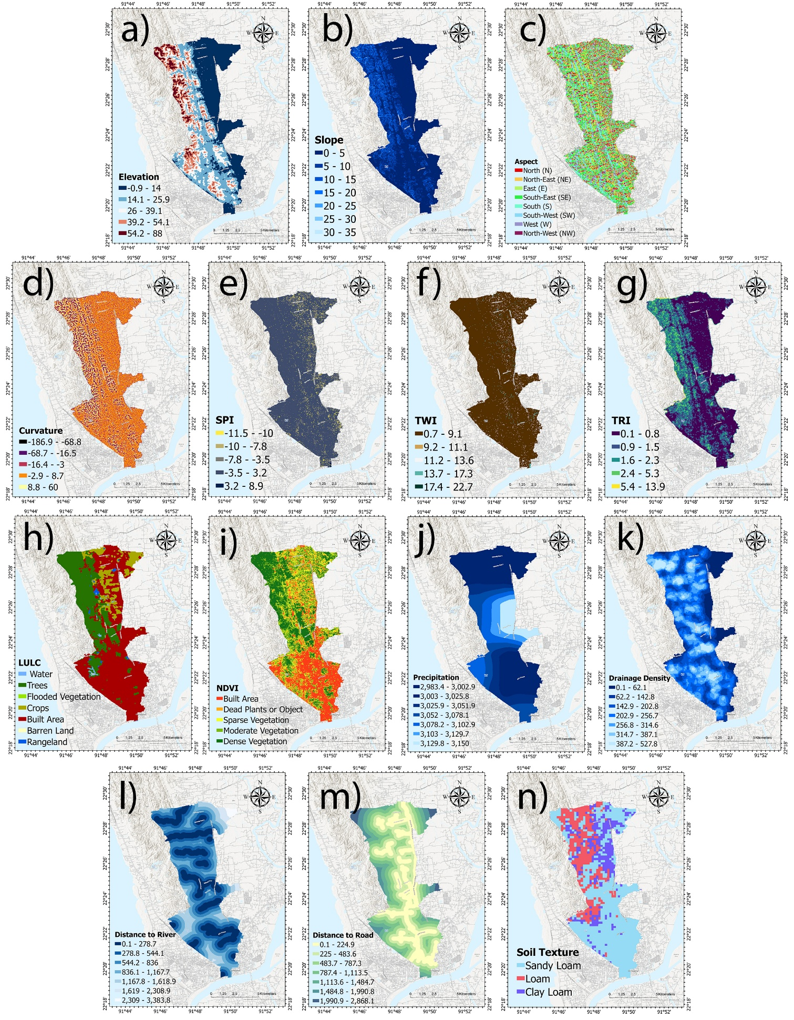
Figure 2: (a)Elevation, (b)Slope, (c)Aspect, (d)Curvature, ISPI, (f)TWI, (g)TRI, (h)LULC, (i)NDVI, (j)Precipitation, (k)Drainage Density, (l)Distance to River, (m)Distance to Road, (n)Soil Texture.

Elevation ranges from −0.9 m to 88 m in the study area and is classified into five altitudinal intervals. Slope values were grouped into six classes (0–5°, 5–10°, 10–15°, 15–20°, 20–25°, and 25–35°), representing terrain ranging from gentle to moderately steep. Aspect was categorized into eight cardinal directions. Curvature values were divided into five classes representing concave to convex terrain forms. SPI and TWI were derived from hydrological analysis of the DEM and categorized into five classes each, representing increasing flow accumulation and soil moisture potential, respectively. TRI was grouped into five classes to represent increasing terrain ruggedness. The LULC layer was classified into seven categories: water bodies, trees, flooded vegetation, cropland, built-up areas, barren land, and rangeland. NDVI values were reclassified into five vegetation-density levels. Mean annual precipitation ranges between approximately 2,983 mm and 3,150 mm and was grouped into seven intensity classes. Drainage density was categorized into seven classes reflecting increasing channel concentration. Euclidean distances to rivers and roads were classified into seven proximity intervals to represent the influence of fluvial erosion and the intensity of anthropogenic disturbance. Soil texture was categorized into three dominant classes: sandy loam, loam, and clay loam.

Methodology
This study presents an integrated Bayesian machine-learning framework for landslide susceptibility mapping (LSM), which incorporates flexibility-revealed preposing, probabilistic modeling, multilevel testing, and uncertainty-aware spatial deployment. The workflow began with compiling historical landslide records and their associated conditioning factors, followed by standard preprocessing operations. Multivariate analysis, assessment, imputation, and feature scaling were conducted only on the training data set (Achu et al. 2023) beginning with an exploratory data analysis (EDA). All steps were performed carefully to prevent data leakage. Both classes of models (Bayesian: Bayesian Logistic Regression, Gaussian Process Classifier; conventional benchmark) were trained using the same pipeline configurations to ensure a fair comparison. The proposed model performance was evaluated using a comprehensive validation strategy, along with repeated stratified cross-validation, spatial block cross-validation to assess the geographic generalization of results, and an independent holdout test for external evaluation (Afzal et al. 2025). Discrimination, calibration, and probabilistic error metrics were jointly analyzed, and formal statistical tests were applied to identify groups that differ significantly. Final model selection was also based on performance assessments within a weighted multi-criteria rank-based framework that balances predictive power, spatial stability, and calibration fit. The chosen Bayesian model was then retrained on the entire dataset to produce a bivariate map of landslide susceptibility and uncertainty. The methodological flow chart is shown in Figure 3.
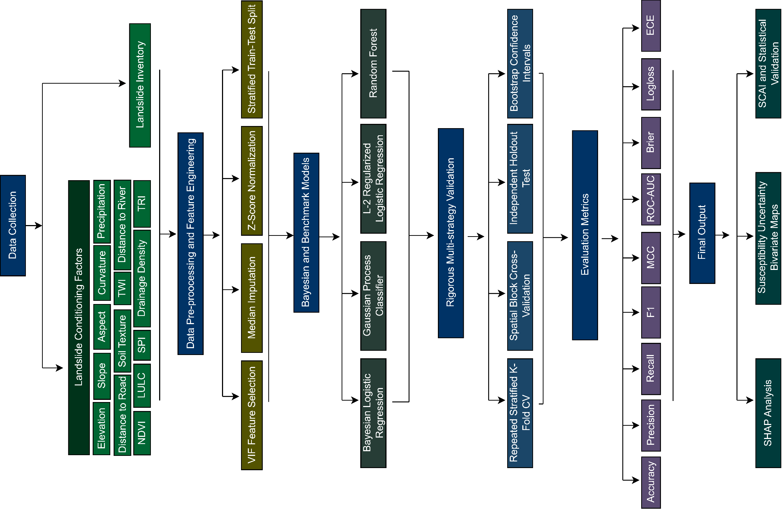
Figure 3: Methodological workflow for Bayesian deployment with benchmark comparison.

Multicollinearity screening
Multicollinearity was evaluated among the conditioning factors prior to model development to ensure that regression-based and kernel-based models would be statistically stable and interpretable (Bobb et al. 2018). Predictor intercorrelation induces inflation in variance estimates, destabilizes coefficient estimation, and distorts posterior uncertainty of inference based on Bayesian frameworks (Gregorich et al. 2021). Hence, the multicollinearity diagnostics were carried out only on the training subset to avoid any information leakage into the validation stages (Rahaman and Abdul 2024).
In this study, multicollinearity was assessed using the Variance Inflation Factor (VIF) and its reciprocal, the Tolerance (TOL) index. For each predictor variable $X_{j}$, a regression model was fitted against all remaining predictors, and the corresponding coefficient of determination $R_{j}^{2}$was computed. The tolerance value is defined as:
$$\begin{matrix} & {\text{Tolerance}}_{j}=1-R_{j}^{2} & & \text{(1)}\end{matrix}$$The Variance Inflation Factor is then calculated as:
$$\begin{matrix} & {\text{VIF}}_{j}=\frac{1}{{\text{Tolerance}}_{j}} & & \text{(2)}\end{matrix}$$where $R_{j}^{2}$represents the coefficient of determination obtained when the $j^{th}$ The predictor is regressed on the remaining predictors.
Following established recommendations in susceptibility modeling studies, predictors with VIF values greater than 5 were considered indicative of substantial multicollinearity and were iteratively removed. The iterative elimination process continued until all remaining predictors met the predefined VIF criterion (Manczinger et al. 2025).

Machine Learning Models
Four classification algorithms were implemented within a unified preprocessing and validation framework to ensure methodological consistency, while conventional models were included as discriminative benchmarks. These algorithms were selected based on various studies in the literature (Gupta and Sivakumar 2025).

Bayesian Logistic Regression (BLR)
Bayesian Logistic Regression was implemented as a probabilistic linear classifier using a logit link function (Genkin et al. 2007). Regression coefficients were treated as random variables with zero-mean Gaussian priors (Kumar et al. 2026), and the intercept remained unpenalized (Ghosal et al. 2025). The Laplace method was used for posterior inference, employing a multivariate normal approximation centered around the maximum (Garcia et al. 2024). Probability predictions were obtained by marginalizing the posterior distribution of model parameters, enabling direct quantification of predictive uncertainty via propagation of posterior variance (Liao et al. 2024). The BLR model was chosen for its interpretability, regularization under moderate sample sizes, and use in probabilistic landslide susceptibility modeling (Das et al. 2012).

Gaussian Process Classifier (GPC)
The Gaussian Process Classifier was used as a non-parametric Bayesian model that can learn non-linear relationships between conditioning factors and landslide occurrence (Qiu et al. 2024). A Gaussian Process prior with a Matérn covariance kernel was defined that provides an adequate trade-off between flexibility and smoothness to model spatially structured processes in the environment (Arrogante-Funes et al. 2024b). Due to the non-Gaussian nature of the likelihood, posterior inference was approximated via the Laplace method (Lombardo et al. 2018). The GPC not only produces predictive probabilities, but also latent variance estimates, allowing explicit characterization of epistemic uncertainty and more complicated decision boundaries in comparison to linear models (Thelen et al. 2024).

L2-Regularized Logistic Regression (LR-L2)
A simple linear benchmark, L2-regularized Logistic Regression, was also used in this study. Ridge regularization was applied to constrain coefficients, combat overfitting, and enhance generalizability (Şensoy et al. 2020). Class imbalance was addressed through balanced class weighting. Unlike its Bayesian counterpart, LR-L2 provides point estimates of parameters without posterior uncertainty, and includes it to evaluate the added value of Bayesian inference in terms of calibration and spatial robustness (Black et al. 2022).

Random Forest (RF)
Random Forest was implemented as an ensemble tree-based classifier using bootstrap aggregation and random feature selection. The model captures non-linear interactions without parametric assumptions (Dal Seno et al. 2024). A balanced subsampling strategy was adopted to address class imbalance. Although RF typically demonstrates strong discriminative performance in landslide susceptibility studies, it does not provide coherent posterior uncertainty; therefore, it was treated strictly as a benchmark model in this research (Lv et al. 2025).

Validation design
To obtain statistically robust and spatially realistic performance estimates, three complementary validation strategies were implemented. First, repeated stratified cross-validation (5-fold × 3 repeats) was applied to the training subset to generate stable average metrics while preserving class proportions within each fold (Porrello et al. 2019). Second, stratified sampling was employed to reserve 20% of the data as an independent holdout set untouched by model development and reserved solely for external evaluation. Third, spatial block cross-validation was performed using GroupKFold and spatial clusters derived from KMeans clustering in geographic coordinates (Dey et al. 2024). This approach maintains spatial separation between training and test samples, approximating spatial independence and curbing metric inflation resulting from spatial autocorrelation (Singh et al. 2025).

Evaluation metrics
A wide range of metrics for discrimination, robustness, and probabilistic calibration were used to evaluate the model, ensuring a balanced and statistically meaningful assessment of landslide-susceptibility predictions. Both threshold-dependent and threshold-independent measures were considered (Halder et al. 2025). Metrics based on confusion matrices summarize concordance in class predictions at a fixed decision threshold, whereas ranking-based metrics characterize the ability of the model to distinguish between landslide and non-landslide locations irrespective of threshold selection (Tehrani et al. 2022). As the suggested framework primarily centers on probabilistic forecasting, especially for Bayesian models, proper scoring rules were integrated to evaluate the goodness of predicted probabilities, not just class labels (Mwakapesa et al. 2024). Additionally, calibration metrics were added to consider the reliability between predicted susceptibility probabilities and observed landslide occurrence (Pareek et al. 2024). This integrated evaluation approach guarantees a simultaneous assessment of discrimination strength, class-imbalance robustness, probability accuracy, and calibration reliability before model selection and spatial deployment.
$$\text{Accuracy}=\frac{TP+TN}{TP+TN+FP+FN}$$ | 3
$$\text{Precision}=\frac{TP}{TP+FP}$$ | 4
$$\text{Recall}=\frac{TP}{TP+FN}$$ | 5
$$\text{F1}=2⋅\frac{\text{Precision}⋅\text{Recall}}{\text{Precision}+\text{Recall}}$$ | 6
$$\text{MCC}=\frac{TP⋅TN-FP⋅FN}{\sqrt{\left(TP+FP)(TP+FN)(TN+FP)(TN+FN\right)}}$$ | 7
$$\text{TPR}=\frac{TP}{TP+FN}$$ | 8
$$\text{FPR}=\frac{FP}{FP+TN}$$ | 9
$$\text{Brier}=\frac{1}{n}\sum_{i=1}^{n}{(}p_{i}-y_{i})^{2}$$ | 10
$$\text{LogLoss}=-\frac{1}{n}\sum_{i=1}^{n}{\left[y_{i}log⁡(p_{i})+(1-y_{i})log⁡(1-p_{i})\right]}$$ | 11
$$ECE=\sum_{k=1}^{K}{\frac{n_{k}}{n}}\left|acc\left(B_{k}\right)-conf\left(B_{k}\right)\right|$$ | 12
Where:
$TP$, $TN$, $FP$, $FN$denote true positives, true negatives, false positives, and false negatives; $p_{i}$is the predicted probability for observation $i$; $y_{i}∈\{0,1\}$is the observed label;$n$is the total number of samples; $B_{k}$denotes the $k^{th}$probability bin; $n_{k}$is the number of samples in bin $k$; $\text{acc}(B_{k})$is empirical accuracy within the bin $k$; $\text{conf}(B_{k})$is the mean predicted probability in the bin $k$.
This formulation of metrics provides a clear and reproducible way to evaluate and is consistent with both traditional classification semantics and uncertainty-based probabilistic modeling goals.

Model Comparison, Selection, and Spatial Deployment Framework
To evaluate if differences in predictive performance were statistically significant, nonparametric hypothesis testing was performed on repeated cross-validation F1 scores (Mwakapesa et al. 2024). Since several models were assessed in the same folds, differences in global performance across groups were assessed using the Friedman test (Yan et al. 2018). Significance was confirmed using the Friedman test (α = 0.05) prior to performing pairwise comparisons to determine specific model differences with the Nemenyi post-hoc test (Gardner and Brooks 2018).
Following the statistical comparison, final model selection was performed using a weighted rank-based multi-criteria framework that integrates discrimination performance, spatial robustness, and probabilistic calibration. Each model was ranked across five criteria: (i) cross-validation MCC (20%), (ii) holdout MCC (35%), (iii) spatial block MCC (30%), (iv) holdout Brier score (10%, lower is better), and (v) holdout Expected Calibration Error (5%, lower is better) (O’Malley et al. 2024). The composite score was computed as a weighted average of normalized ranks; deployment was restricted to ensure consistency between the susceptibility-mapping and uncertainty-representation objectives, as hazard management relies on well-calibrated probabilities rather than deterministic point predictions. (Torizin et al. 2024).
In order to promote decision-oriented interpretation, susceptibility and predictive uncertainty were jointly visualized using a bivariate classification scheme (Schlögl et al. 2025). Quantile thresholds were applied to obtain three ordinal classes (low, moderate, and high) for continuous susceptibility probabilities, as well as for normalised predictive variance class variables, thereby preserving a balanced spatial representation. The resulting 3 × 3 matrix was used to combine these classes into nine composite categories representing all combinations of susceptibility–uncertainty (Ren et al. 2024). In this way, it permits the concurrent identification of high-susceptibility regions, confirmed by low infrastructural estimates (high susceptibility–low uncertainty), midzones with mixed characteristics (moderate combinations), and spatially uncertain predictions associated with significant indeterminacy. The bivariate representation enhances transparency by clearly demarcating confidently identified hazard hotspots from those where elevated susceptibility co-occurs with reduced certainty in the predictions of the model (Agrawal and Dixit 2023).
To evaluate the effectiveness of spatial concentration for susceptibility classes, the Seed Cell Area Index (SCAI) was computed for each tier. SCAI quantifies the ratio between the spatial proportion of a susceptibility class and the proportion of landslides occurring within that class (Singh et al. 2024). Lower SCAI values in higher susceptibility tiers indicate improved concentration of landslides within smaller mapped areas, thereby reflecting more efficient hazard delineation (Di Napoli et al. 2023).

Results

Multicollinearity analysis
Multicollinearity diagnostics confirmed that all fourteen conditioning factors met the predefined thresholds (VIF < 5; TOL > 0.20). No predictors were excluded in this dataset, as shown in Figure 4. VIF values ranged from 1.12 to 3.32, indicating low to moderate multicollinearity. Tolerance values (0.30–0.90) further confirmed the absence of critical redundancy in the data set. Overall, the predictor set was statistically stable and suitable for both Bayesian and benchmark modeling for landslide susceptibility mapping.
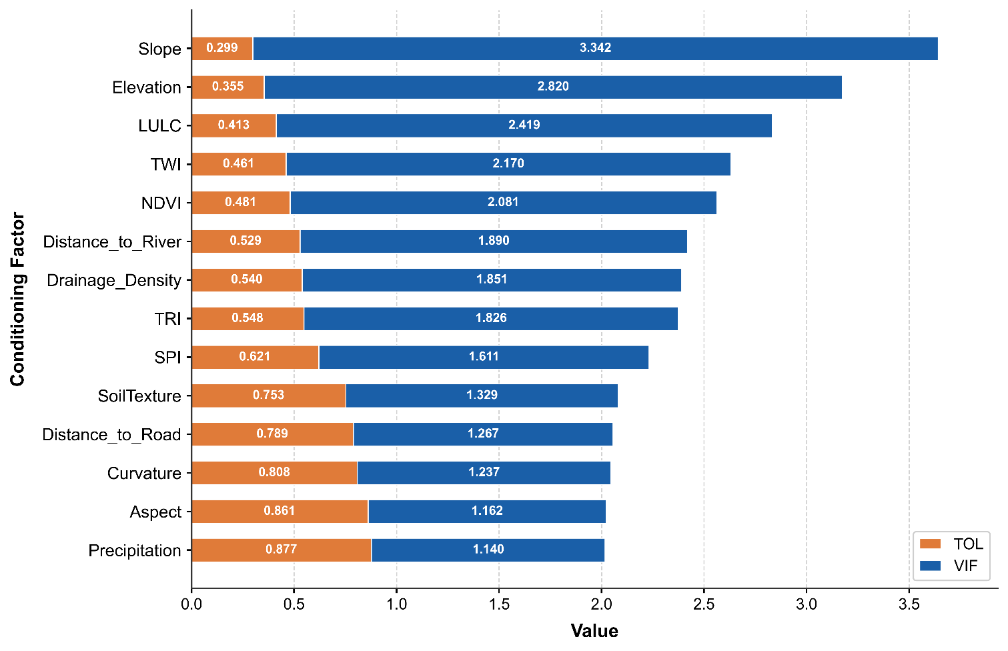
Figure 4: VIF and tolerance profile for the conditioning factors.

Holdout performance and multi-metric comparison
In the independent holdout evaluation given in Table 2, Random Forest showed the strongest discrimination (ROC-AUC = 0.866; PR-AUC = 0.865) and overall agreement (MCC = 0.611). GPC (ROC-AUC = 0.821) achieved competitive discrimination among the Bayesian candidates and yielded the lowest calibration error overall (ECE = 0.084), indicating that GPC produced more reliable probabilities compared with BLR. Despite a high recall (0.774) reported by Bayesian logistic regression, lower precision and a higher Brier score indicated weaker probabilistic performance. The performance curves in Figure 5 for the AUC value confirm that RF prevails in the discrimination space.
Table 2: Holdout test performance (20% split).
Model | Accuracy | Precision | Recall | F1 | MCC | ROC-AUC | PR-AUC | Brier | ECE
RF | 0.811 | 0.774 | 0.774 | 0.774 | 0.611 | 0.866 | 0.865 | 0.153 | 0.120
GPC | 0.743 | 0.676 | 0.742 | 0.708 | 0.481 | 0.821 | 0.814 | 0.172 | 0.084
LogReg_L2 | 0.703 | 0.615 | 0.774 | 0.686 | 0.420 | 0.768 | 0.667 | 0.203 | 0.110
BLR | 0.676 | 0.606 | 0.645 | 0.625 | 0.340 | 0.775 | 0.723 | 0.193 | 0.112
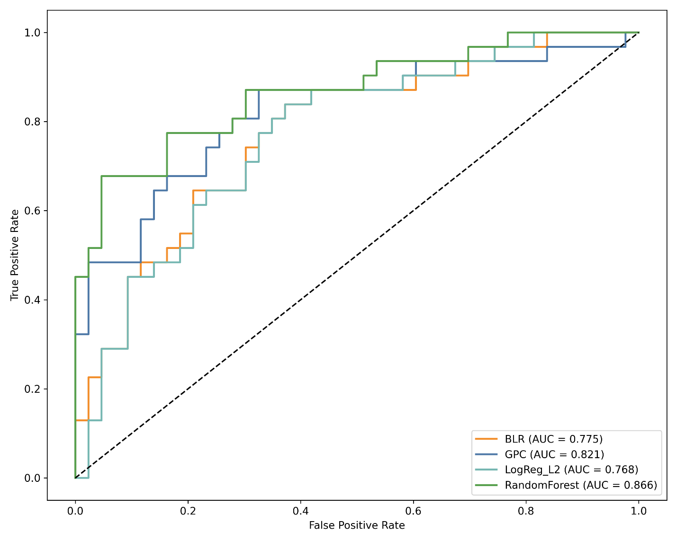
Figure 5: Holdout (test set) performance: ROC curves with AUC values.
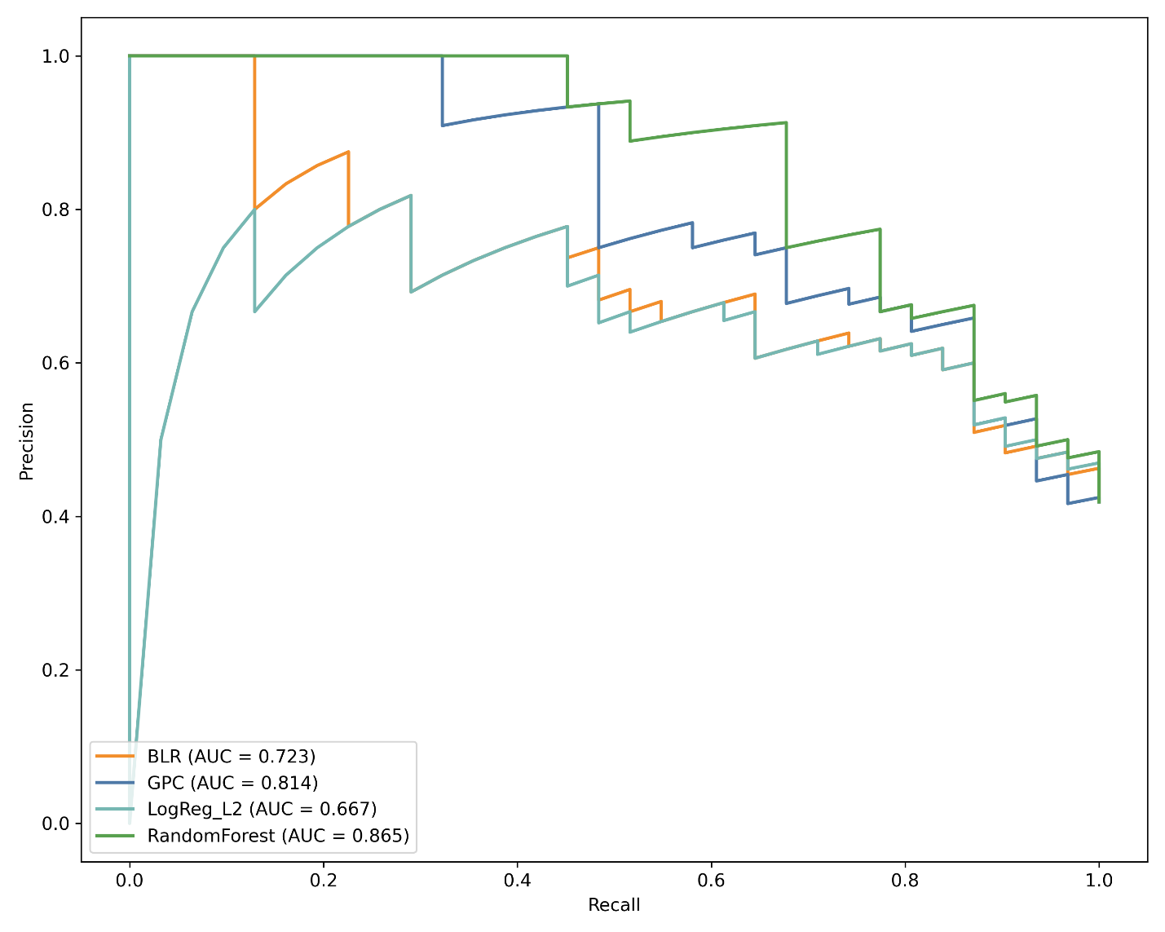
Figure 6: Holdout (test set) performance: Precision–Recall curves with PR-AUC values

Cross-validation and spatial generalisation
Repeated stratified CV produced higher MCC and ROC-AUC values than spatial block CV (Table 3), indicating performance inflation under non-spatial validation. Spatial blocking reduced MCC by approximately 35% for RF (0.498 to 0.323) and 42% for GPC (0.450 to 0.259), highlighting the challenge of geographic transferability. Despite this degradation, model ranking remained stable, with RF and GPC consistently outperforming linear baselines under both validation schemes.

Table 3: Repeated CV and spatial block CV summary
Model | CV MCC (mean) | CV ROC-AUC (mean) | Spatial MCC (mean) | Spatial ROC-AUC (mean)
RF | 0.498 | 0.849 | 0.323 | 0.805
GPC | 0.450 | 0.836 | 0.259 | 0.769
LogReg_L2 | 0.433 | 0.756 | 0.214 | 0.709
BLR | 0.388 | 0.757 | 0.226 | 0.709

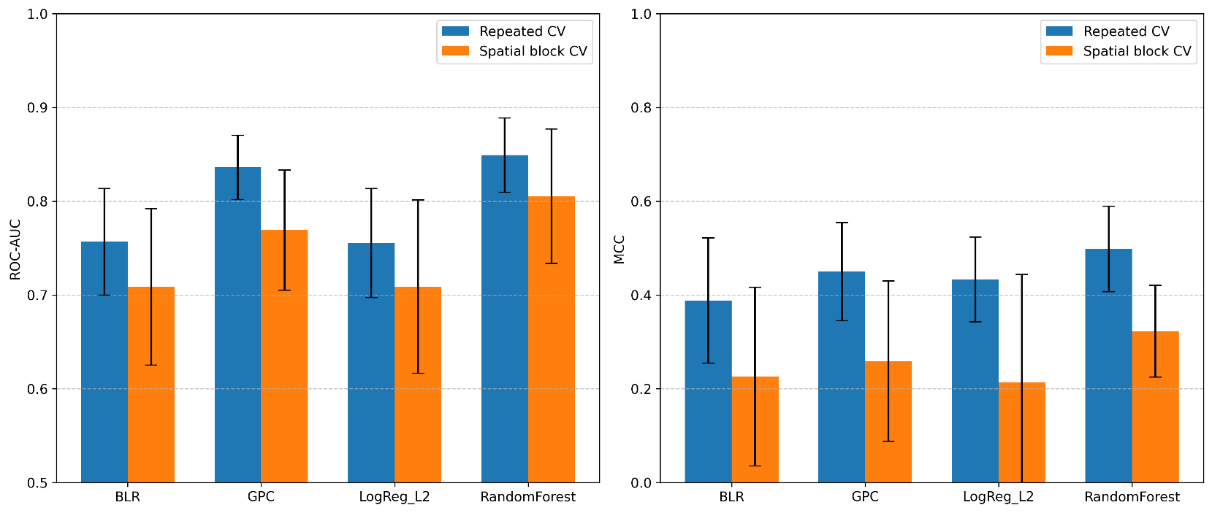
Figure 7: Comparison of repeated stratified CV and spatial block CV performance (MCC and ROC-AUC) across models.

Statistical significance and model ranking
The Friedman test on repeated cross-validation F1 scores showed significant differences between models (χ² = 17.73, p < 0.001). Weighted multi-metric ranking was performed next; Random Forest was ranked first, GPC, LogReg_L2, and BLR performed last. However, only Bayesian candidates were deployed because explicit representation of uncertainty was needed, and RF scored the highest composite rank. Of these, GPC exhibited the highest overall calibration stability and spatial robustness and thus was chosen for final susceptibility and uncertainty mapping.

In terms of calibration, the leading mode, i.e., random forest, in this study performs poorly, with an Expected Calibration Error (ECE) of 0.120. Figure 8 shows the calibration curve (reliability diagram), which assesses how well predicted probabilities align with actual outcomes. The closer a model’s curve follows the diagonal, the better calibrated it is. The reported ECE quantifies this deviation: lower ECE indicates better calibration. Here, random forest fails. Highlight that GPC achieved the lowest Expected Calibration Error (ECE = 0.084; hence, it implicitly portrays the best model in terms of calibration. Gaussian Processes yield well-calibrated probabilities because they are fully Bayesian, explicitly model uncertainty, and adapt smoothly to nonlinear patterns without becoming overconfident. Areas like the Chittagong Hill Tracts, where data are limited, require reliability over deterministic classification. Gaussian Processes meet this requirement, with good calibration, and other accuracy metrics are also second-best in our study.

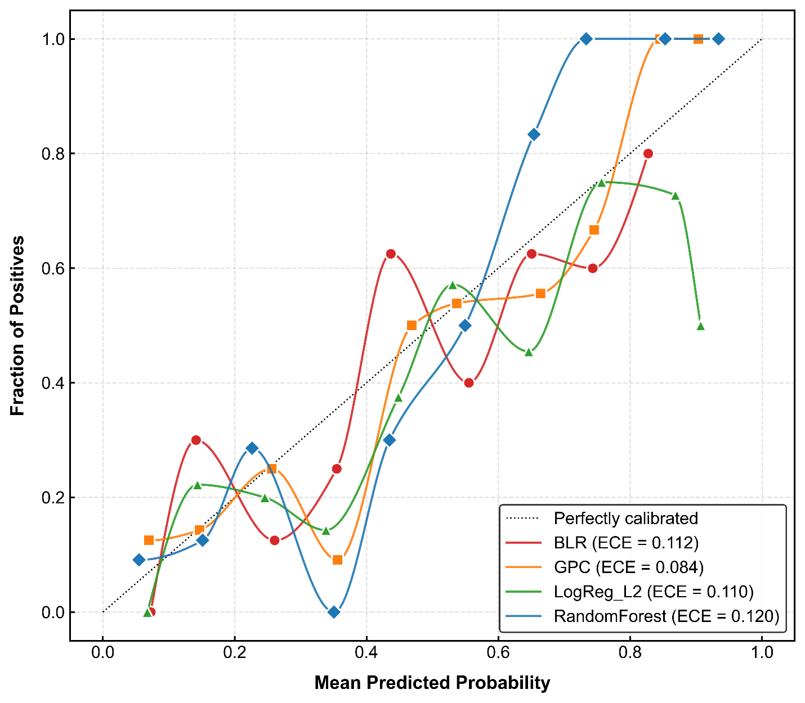
Figure 8: Holdout (test set) performance: Smoothed calibration curves; the dashed line indicates perfect calibration

Interpretation of Conditioning Factor Contributions
SHAP analysis (Figure 9a) identified Elevation, Precipitation, and LULC as the most dominant predictors. Increased gravitational stress and slope-gradient effects at higher elevations positively contribute to SHAP, while the positive contributions from high precipitation values arise from hydrological destabilization mechanisms via increased pore-water pressure. The effect of LULC was found to be class-specific, suggesting that slope stability depends on vegetation cover and human disturbance. The waterfall plot (Figure 9b) shows that combined feature interactions propel predictions from the baseline of the model to a high-susceptibility local outcome scale.
a) | 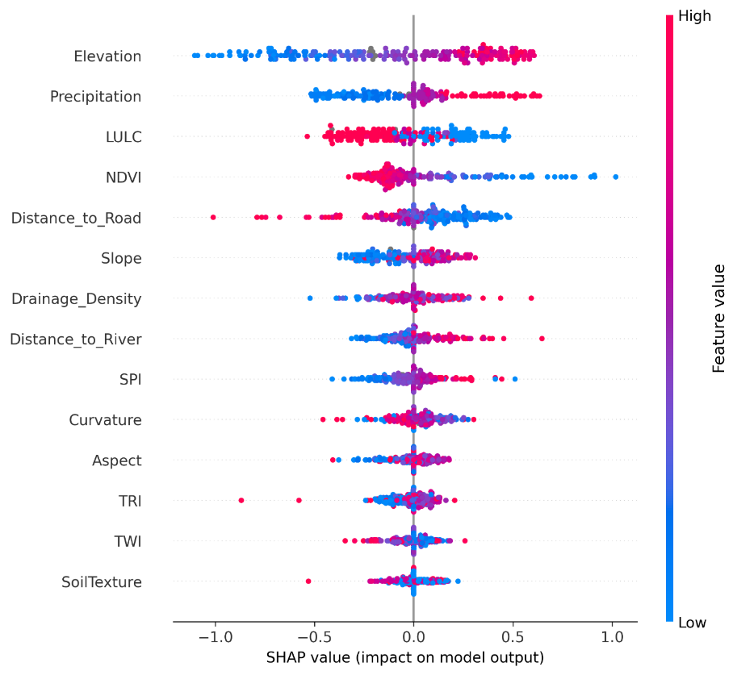
b) | 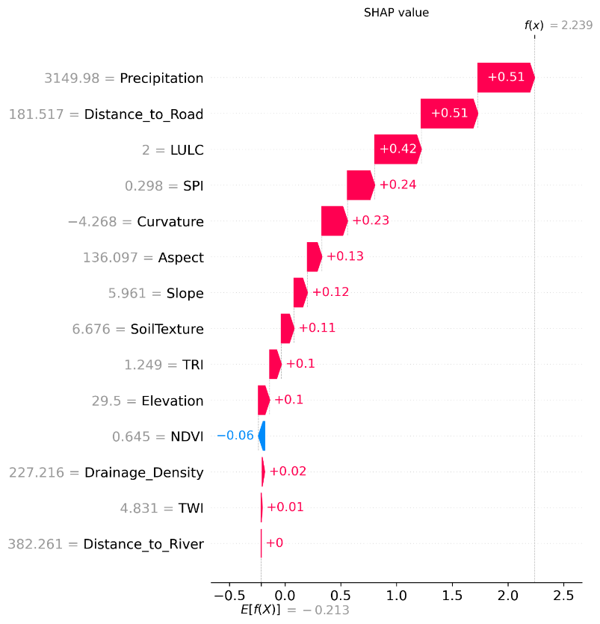
Figure 9: Interpretation of the GPC via SHAP on holdout dataset (a) SHAP summary (beeswarm) plot of the aggregated contribution and direction of influence of each conditioning factor to model predictions. (b) SHAP waterfall plot for a representative holdout sample showing the cumulative contribution of individual features from the expected value $E[f(X)]$to the final predicted output $f(x)$.

Integrated Susceptibility–Uncertainty Patterns
Figure 10 illustrates a 3×3 bivariate classification of susceptibility and predictive uncertainty jointly conditioned on the output of the deployed GPC model. This modelling facilitates joint evaluation of forecasted hazard strength and model certainty in a spatial context.
Areas of high susceptibility are mostly clustered along the central and southeastern hill sectors of the study area, exhibiting well-defined spatial clusters that track steep terrain and anthropogenically disturbed slopes. A significant fraction of these zones falls into classes with uncertainty on the low- or medium-side of the scale, implying that the local density of training data supports stable posterior predictions. Regions like these are high-confidence landslide hotspots.
On the other hand, localized patches exhibit high susceptibility and high uncertainty. These zones primarily develop in border terrain, vadose zones, and peripheral hill zones. Areas where the predicted probability and variance were both high indicate lower posterior stability, perhaps due to heterogeneous geomorphological conditions or a training inventory that is not representative of those areas. Data in these areas should be interpreted with caution and potentially could benefit from localized field-based validation.
Low-susceptibility areas predominate in the northeastern and relatively flat sectors of the study area. These areas are typically regions of low predictive uncertainty, providing confidence in mapped stable terrain. Nonetheless, neighborhoods of moderate uncertainty on low-susceptibility classes reveal model sensitivity near the susceptibility threshold for isolated sectors.
Overall, the bivariate analysis shows that most high-susceptibility clusters are underpinned by relatively low uncertainty, providing greater confidence in hazard delineation while transparently highlighting areas where predictive certainty is lessened.
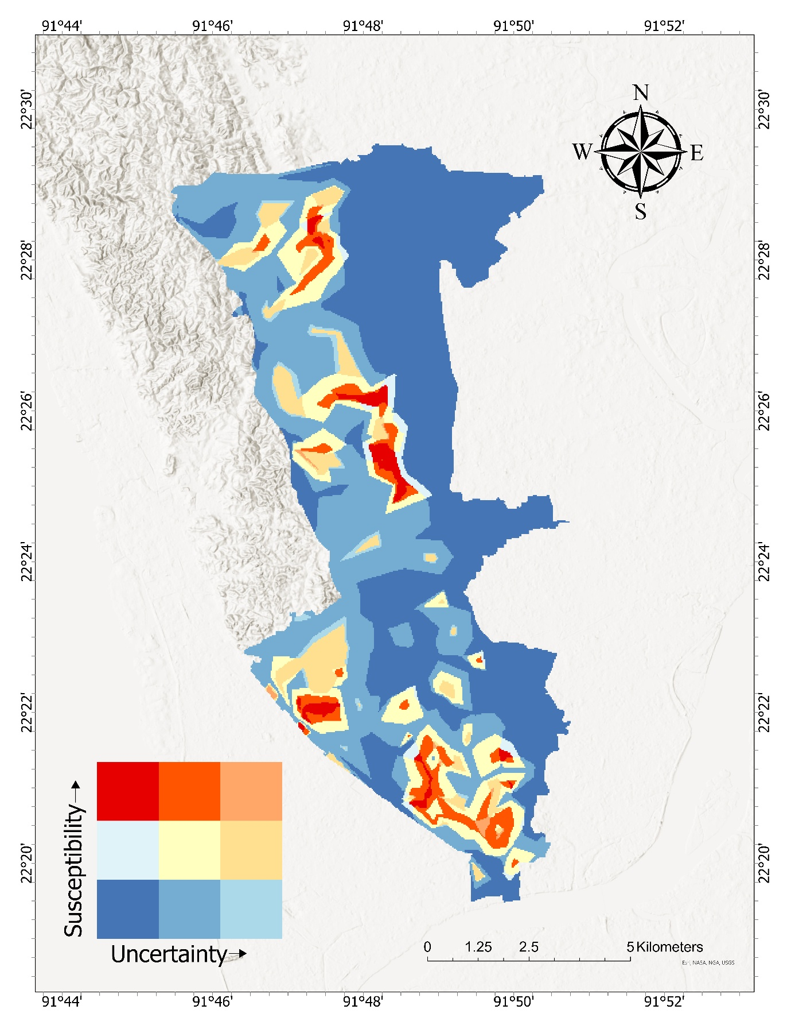
Figure 10: Bivariate landslide susceptibility–uncertainty map based on deployed Gaussian Process Classifier. Susceptibility (vertical axis) and predictive uncertainty (horizontal axis) were categorized into three ordinal classes using quantile thresholds, and the resulting categories were combined into a 3 × 3 matrix. The color of the squares indicates the combined classification of susceptibility and predictive uncertainty.

Susceptibility stratification is robust, as shown by SCAI analysis (Table 4). More specifically, the Very High class was predictive because it accounted for 78.71% of all mapped landslides but covered only 9.47% of the study area. On the other hand, the Very Low and Low classes, which together cover over 50% of the area, account for only 1.3% of the landslides. The significant decrease in SCAI from Very Low (45.53) to Very High (0.12) indicates good spatial discrimination and the importance of hazard zonation.
Table 4 SCAI by susceptibility tier
Tier | Area % | Landslide % | Landslide Count | SCAI
Very Low | 29.37 | 0.65 | 1 | 45.53
Low | 23.16 | 0.65 | 1 | 35.90
Moderate | 24.04 | 5.81 | 9 | 4.14
High | 13.96 | 14.19 | 22 | 0.98
Very High | 9.47 | 78.71 | 122 | 0.12

Discussion
The comparative evaluation of deterministic and Bayesian classifiers reveals the trade-off between discriminative strength and probabilistic reliability. Random Forest showed the best discrimination on the independent holdout dataset, confirming its ability to model nonlinear interactions between geomorphological and hydrological predictors. Although the Random Forest achieved the highest ROC-AUC and MCC scores, the Gaussian Process Classifier (GPC) exhibited the lowest Expected Calibration Error, indicating the best agreement between predicted probabilities and observed landslide frequency. Hence, the multi-criteria framework with weights focuses on achieving balanced performance across discrimination, calibration, and spatial robustness to select which one to deploy from GPC. Its selection in the current study was additionally justified by its improved predictive performance and lower false-positive rates compared with other models, resulting in a more reliable and robust evaluation of landslide susceptibility (Singh et al. 2025).
The explicit comparison between repeated stratified cross-validation and spatial block cross-validation highlights the necessity of geographically realistic validation schemes (Wang et al. 2023). Performance under spatial blocking validates that random cross-validation overestimates metrics due to spatial autocorrelation effects in training and testing samples (Wang et al. 2023). However, differences between models persisted across test schemes, indicating stable model behavior. Bayesian models can further reduce overconfidence by representing the uncertainty in extrapolated regions (Naceur et al. 2026). The increased predictive variance at susceptibility transition zones indicates either insufficient local training support or lower posterior certainty.
The bivariate susceptibility–uncertainty representation refines hazard interpretation by differentiating between robust and uncertain hotspots. In central hill sectors, high susceptibility coincides with low posterior variance, indicating strong model support. Peripheral hill margins exhibit elevated susceptibility with higher uncertainty, suggesting extrapolation beyond well-represented conditions. The Seed Cell Area Index (SCAI) results validate the spatial concentration efficiency of the final model. The Very High susceptibility class contains nearly four-fifths of mapped landslides while occupying less than one-tenth of the study area, indicating strong stratification. The monotonic decline in SCAI values confirms the effectiveness of hazard zonation.
Interpretability analysis based on SHAP values provides geomorphological plausibility. Elevation, precipitation, and land use/land cover emerged as dominant predictors. The consistency of feature importance across validation schemes indicates alignment with established physical understanding.
Despite its methodological rigor, the study has limitations. The landslide inventory remains modest in size, and additional temporal records could enhance posterior stability. Rainfall was incorporated as a climatological layer rather than event-based intensity, limiting temporal sensitivity (Shi et al. 2025). Spatial interpolation may smooth localized micro-topographic effects. Future research may incorporate event-scale rainfall thresholds, hierarchical spatial priors, or hybrid physics–Bayesian neural network frameworks (Mafigiri et al. 2025).

Conclusion
This study develops and evaluates an uncertainty-aware landslide-susceptibility framework using Bayesian and deterministic classifiers with a unified preprocessing and validation strategy for the hilly areas of the Chattogram Metropolitan Area. The findings showed that evaluation metrics alone can overestimate predictive capability when spatial autocorrelation is accounted for. Overall, although Random Forest delivered the best discrimination performance, its predictive capability was hindered by inadequate probabilistic calibration and uncertainty estimation, unlike the Gaussian Process Classifier. All the same, GPC provided nearly comparable predictions and improved performance by offering well-calibrated uncertainty estimates, which are vital for risk-informed decision-making. With the Bayesian model deployed, continuous surfaces of susceptibility and predictive variance were modeled and then combined via bivariate classification to separate robust hazard hotspots from spatially uncertain predictions. Hazard stratification was also supported by spatial concentration analyses, with most historical landslides concentrated in a small fraction of the mapped area, and some clustered within it. This study integrates discrimination assessment, spatial cross-validation, calibration analysis, statistical comparison, and uncertainty visuals into a workflow, advancing landslide susceptibility modeling toward a transparent, decision-oriented framework. This is especially suited for fast-urbanizing, data-poor hill terrains where hazard prioritization considers both probability and confidence. Concepts like an area of applicability could further improve transparency by indicating where predictions are reliable.
References
Achu AL, Aju CD, Di Napoli M, et al (2023) Machine-learning based landslide susceptibility modelling with emphasis on uncertainty analysis. Geosci Front 14:101657. https://doi.org/10.1016/j.gsf.2023.101657
Adnan MSG, Rahman MS, Ahmed N, et al (2020) Improving Spatial Agreement in Machine Learning-Based Landslide Susceptibility Mapping. Remote Sens 12:3347–3347. https://doi.org/10.3390/rs12203347
Afzal H, Amjad M, Raza A, et al (2025) Incorporating soil information with machine learning for crop recommendation to improve agricultural output. Sci Rep 15:8560. https://doi.org/10.1038/s41598-025-88676-z
Agrawal N, Dixit J (2023) GIS-based landslide susceptibility mapping of the Meghalaya-Shillong Plateau region using machine learning algorithms. Bull Eng Geol Environ 82:. https://doi.org/10.1007/s10064-023-03188-2
Ahmed B (2014) Landslide susceptibility mapping using multi-criteria evaluation techniques in Chittagong Metropolitan Area, Bangladesh. Landslides 12:1077–1095. https://doi.org/10.1007/s10346-014-0521-x
Arrogante-Funes P, Bruzón AG, Álvarez-Ripado A, et al (2024a) Assessment of the regeneration of landslides areas using unsupervised and supervised methods and explainable machine learning models. Landslides 21:275–290. https://doi.org/10.1007/s10346-023-02154-z
Arrogante-Funes P, Bruzón AG, Álvarez-Ripado A, et al (2024b) Assessment of the regeneration of landslides areas using unsupervised and supervised methods and explainable machine learning models. Landslides 21:275–290. https://doi.org/10.1007/s10346-023-02154-z
Azad MA, Kainthola A, Fissha Y, et al (2025) Empirical and numerical hill slope health evaluation at Malling Nala, NH-505, Himachal Pradesh, India. Int J Geo-Eng 16:4. https://doi.org/10.1186/s40703-025-00233-9
Biswas N, Islam KMA, Efty EA, et al (2026) Ensemble deep learning framework for landslide susceptibility mapping and road vulnerability index development in the Chittagong Hill Tracts, Bangladesh. Geomat Nat Hazards Risk 17:. https://doi.org/10.1080/19475705.2026.2634207
Black B, Strien MJ van, Adde A, Grêt‐Regamey A (2022) Re-considering the status quo: Improving calibration of land use change models through validation of transition potential predictions. Environ Model Softw 159:105574–105574. https://doi.org/10.1016/j.envsoft.2022.105574
Bobb JF, Henn BC, Valeri L, Coull BA (2018) Statistical software for analyzing the health effects of multiple concurrent exposures via Bayesian kernel machine regression. Environ Health 17:. https://doi.org/10.1186/s12940-018-0413-y
Carleton WC, Klassen S, Niles-Weed J, et al (2023) Bayesian regression versus machine learning for rapid age estimation of archaeological features identified with lidar at Angkor. Sci Rep 13:17913. https://doi.org/10.1038/s41598-023-44875-0
Chowdhury MS, Rahman MN, Sheikh MS, et al (2023) GIS-based landslide susceptibility mapping using logistic regression, random forest and decision and regression tree models in Chattogram District, Bangladesh. Heliyon 10:. https://doi.org/10.1016/j.heliyon.2023.e23424
Cruz A, Karimzadeh S, Chieffo N, et al (2024) A Review of Probabilistic Approaches for Assessing the Liquefaction Hazard in Urban Areas. Arch Comput Methods Eng 31:4673–4708. https://doi.org/10.1007/s11831-024-10124-4
Cunha RLF, Silva B, Netto MAS (2018) A Scalable Machine Learning System for Pre-Season Agriculture Yield Forecast. 423–430. https://doi.org/10.1109/escience.2018.00131
Dal Seno N, Evangelista D, Piccolomini E, Berti M (2024) Comparative analysis of conventional and machine learning techniques for rainfall threshold evaluation under complex geological conditions. Landslides 21:2893–2911. https://doi.org/10.1007/s10346-024-02336-3
Das I, Stein A, Kerle N, Dadhwal VK (2012) Landslide susceptibility mapping along road corridors in the Indian Himalayas using Bayesian logistic regression models. Geomorphology 179:116–125. https://doi.org/10.1016/j.geomorph.2012.08.004
Dey B, Ferdous J, Ahmed R (2024) Machine learning based recommendation of agricultural and horticultural crop farming in India under the regime of NPK, soil pH and three climatic variables. Heliyon 10:e25112. https://doi.org/10.1016/j.heliyon.2024.e25112
Di Napoli M, Miele P, Guerriero L, et al (2023) Multitemporal relative landslide exposure and risk analysis for the sustainable development of rapidly growing cities. Landslides 20:1781–1795. https://doi.org/10.1007/s10346-023-02065-z
Garcia NL, Rodrigues-Motta M, Migon HS, et al (2024) Unsupervised Bayesian classification for models with scalar and functional covariates. J R Stat Soc Ser C Appl Stat 73:658–681. https://doi.org/10.1093/jrsssc/qlae006
Gardner J, Brooks C (2018) Dropout Model Evaluation in MOOCs. In: Proceedings of the AAAI Conference on Artificial Intelligence. Association for the Advancement of Artificial Intelligence
Genkin A, Lewis D, Madigan D (2007) Large-Scale Bayesian Logistic Regression for Text Categorization. Technometrics 49:291–304. https://doi.org/10.1198/004017007000000245
Ghosal P, De S, Ghosh J (2025) An Online Algorithm for Bayesian Variable Selection in Logistic Regression Models With Streaming Data. ArXiv Cornell Univ. https://doi.org/10.48550/arxiv.2501.10930
Gregorich M, Strohmaier S, Dunkler D, Heinze G (2021) Regression with Highly Correlated Predictors: Variable Omission Is Not the Solution. Int J Environ Res Public Health 18:4259–4259. https://doi.org/10.3390/ijerph18084259
Gupta E, Sivakumar R (2025) Response coupling with an auxiliary neural signal for enhancing brain signal detection. Sci Rep 15:6227. https://doi.org/10.1038/s41598-025-87414-9
Hafsa B, Chowdhury MS, Rahman MN (2022) Landslide susceptibility mapping of Rangamati District of Bangladesh using statistical and machine intelligence model. Arab J Geosci 15:. https://doi.org/10.1007/s12517-022-10607-3
Halder K, Srivastava AK, Ghosh A, et al (2025) Improving landslide susceptibility prediction through ensemble recursive feature elimination and meta-learning framework. Sci Rep 15:. https://doi.org/10.1038/s41598-025-87587-3
Hengl T, Jesus JM de, Heuvelink GBM, et al (2017) SoilGrids250m: Global gridded soil information based on machine learning. PLoS ONE 12:. https://doi.org/10.1371/journal.pone.0169748
Hen-Jones R, Zapata C, Jiménez E, et al (2025) Community-scale slope stability assessment of urbanisation scenarios in North Quito, Ecuador. Landslides. https://doi.org/10.1007/s10346-025-02608-6
Huang F, Cao Y, Li W, et al (2024) Uncertainties of landslide susceptibility prediction: influences of different study area scales and mapping unit scales. Int J Coal Sci Technol 11:26. https://doi.org/10.1007/s40789-024-00678-w
Islam MA, Islam MS, Jeet AA (2021) A Geotechnical Investigation of 2017 Chattogram Landslides. Geosciences 11:337–337. https://doi.org/10.3390/geosciences11080337
Koldasbayeva D, Tregubova P, Gasanov M, et al (2024) Challenges in data-driven geospatial modeling for environmental research and practice. Nat. Commun. 15:10700–10700
Kumar A, Pandey G, Kale RV (2026) Ensemble machine learning and deep learning framework for flood susceptibility mapping in the transboundary Rapti River Basin. Environ Earth Sci 85:168. https://doi.org/10.1007/s12665-026-12912-6
Liao H, Wang C, Li Z, et al (2024) Physics-Informed Trajectory Prediction for Autonomous Driving under Missing Observation
Lombardo L, Opitz T, Huser R (2018) Point process-based modeling of multiple debris flow landslides using INLA: an application to the 2009 Messina disaster. Stoch Environ Res Risk Assess 32:2179–2198. https://doi.org/10.1007/s00477-018-1518-0
Lv M, Li K, Cai J, et al (2025) Evaluation of landslide susceptibility based on SMOTE-Tomek sampling and machine learning algorithm. PLoS ONE 20:. https://doi.org/10.1371/journal.pone.0323487
Mafigiri A, Khanan MFA, Abdullah RA (2025) A review of GIS-based landslide susceptibility and hazard modeling considering the influence of topographic parameters on rainfall spatial variability. Model Earth Syst Environ 11:427. https://doi.org/10.1007/s40808-025-02615-5
Manczinger M, Kovács L, Kovács T (2025) Fire susceptibility assessment in the Carpathians using an interpretable framework. Sci Rep 15:. https://doi.org/10.1038/s41598-025-10296-4
Milà C, Ludwig M, Pebesma E, et al (2024) Random forests with spatial proxies for environmental modelling: opportunities and pitfalls. Geosci Model Dev 17:6007–6033. https://doi.org/10.5194/gmd-17-6007-2024
Mirus BB, Woodard J (2023) Bayesian logistic regression and optimized XGBoost models for landslide susceptibility assessment. https://doi.org/10.5194/egusphere-egu23-11586
Murad G, Nawar N, Ashrafi H, et al (2025) Comprehensive Landslide Inventory and Hotspot Analysis in the Chittagong Hill Tracts of Southeastern Bangladesh. In: Proceedings of International Conference on Civil Engineering Research & Innovations
Murad G, Rahman A (2025) Landslide Susceptibility Assessment of Rangamati Hill District Using Deep Learning Method. In: Proceedings of the 8th International Conference on Engineering Research, Innovation and Education
Mwakapesa DS, Lan X, Mao Y (2024) Landslide susceptibility assessment using deep learning considering unbalanced samples distribution. Heliyon 10:. https://doi.org/10.1016/j.heliyon.2024.e30107
Naceur HA, Igmoullan B, Namous M, et al (2026) Integrating geospatial data and hybrid machine learning models for landslide susceptibility assessment in semi-arid environments. Geomat Nat Hazards Risk 17:. https://doi.org/10.1080/19475705.2026.2625403
O’Malley WC, Elbroch LM, Zeller KA, et al (2024) Machine learning allows for large-scale habitat prediction of a wide-ranging carnivore across diverse ecoregions. Landsc Ecol 39:106. https://doi.org/10.1007/s10980-024-01903-2
Pareek T, Bhuyan K, Westen CJ van, et al (2024) Analyzing the posterior predictive capability and usability of landslide susceptibility maps: a case of Kerala, India. Landslides 22:655–670. https://doi.org/10.1007/s10346-024-02389-4
Porrello A, Vincenzi S, Buzzega P, et al (2019) Spotting Insects from Satellites: Modeling the Presence of Culicoides Imicola Through Deep CNNs. 159–166. https://doi.org/10.1109/sitis.2019.00036
Qiu C, Su L, Pasuto A, et al (2024) Economic Risk Assessment of Future Debris Flows by Machine Learning Method. Int J Disaster Risk Sci 15:149–164. https://doi.org/10.1007/s13753-024-00545-x
Rabby YW, Li Y (2019) Landslide Inventory (2001–2017) of Chittagong Hilly Areas, Bangladesh. Data 5:4–4. https://doi.org/10.3390/data5010004
Rahaman SU, Abdul MJ (2024) Quantifying Uncertainty in Economics Policy Predictions: A Bayesian &amp; Monte Carlo based Data-Driven Approach
Rahman MA, Konagai K (2017) Substantiation of debris flow velocity from super-elevation: a numerical approach. Landslides 14:633–647. https://doi.org/10.1007/s10346-016-0725-3
Rahman MdA, Konagai K (2018) A hands-on approach to estimate debris flow velocity for rational mitigation of debris hazard. Can Geotech J 55:941–955. https://doi.org/10.1139/cgj-2017-0211
Ren T, Gao L, Gong W (2024) An ensemble of dynamic rainfall index and machine learning method for spatiotemporal landslide susceptibility modeling. Landslides 21:257–273. https://doi.org/10.1007/s10346-023-02152-1
Rukh G, Akbar S, Rehman G, et al (2024) StackedEnC-AOP: prediction of antioxidant proteins using transform evolutionary and sequential features based multi-scale vector with stacked ensemble learning. BMC Bioinformatics 25:256. https://doi.org/10.1186/s12859-024-05884-6
Schlögl M, Graser A, Spiekermann R, et al (2025) Brief communication: Visualizing uncertainties in landslide susceptibility modelling using bivariate mapping. Nat Hazards Earth Syst Sci 25:1425–1437. https://doi.org/10.5194/nhess-25-1425-2025
Şensoy M, Kaplan L, Cerutti F, Saleki M (2020) Uncertainty-Aware Deep Classifiers Using Generative Models. In: Proceedings of the AAAI Conference on Artificial Intelligence. Association for the Advancement of Artificial Intelligence, pp 5620–5627
Shaker M, Hüllermeier E (2025) Random forest calibration. Knowl-Based Syst 328:114143–114143. https://doi.org/10.1016/j.knosys.2025.114143
Shi SY, Zhou J, Chen XJ, et al (2025) RISK ASSESSMENT OF GEOLOGICAL DISASTERS TRIGGERED BY HEAVY RAINFALL IN MOUNTAINOUS AREAS: A CASE STUDY IN HEBEI PROVINCE, CHINA. Appl Ecol Environ Res 23:5443–5460. https://doi.org/10.15666/aeer/2303_54435460
Singh A, Dhiman N, Niraj KC, Shukla DP (2024) “Ensembled transfer learning approach for error reduction in landslide susceptibility mapping of the data scare region.” Sci Rep 14:. https://doi.org/10.1038/s41598-024-76541-4
Singh G, Rosman B, Byrne MJ, Reynolds C (2025) An earth observation and explainable machine learning approach for determining the drivers of invasive species — a water hyacinth case study. Environ Monit Assess 197:. https://doi.org/10.1007/s10661-025-14517-1
Song Y, Guo J, Ma F, et al (2023) Spatial distribution analysis and application of engineering disturbance disasters in the Himalayan alpine valley. Front Earth Sci 10:. https://doi.org/10.3389/feart.2022.1098631
Stacey J, Salmon K, Janes T, et al (2023) Diverse skill of seasonal dynamical models in forecasting South Asian monsoon precipitation and the influence of ENSO and IOD. Clim Dyn 61:3857–3874. https://doi.org/10.1007/s00382-023-06770-2
Stefanini FM, Ambrosini S, D′Alessandro F (2025) vulneraR: An R Package for Uncertainty Analysis in Coastal Vulnerability Studies. Mathematics 13:3603–3603. https://doi.org/10.3390/math13223603
Tai X, Anderegg WRL, Blanken PD, et al (2020) Hillslope Hydrology Influences the Spatial and Temporal Patterns of Remotely Sensed Ecosystem Productivity. Water Resour Res 56:. https://doi.org/10.1029/2020wr027630
Tehrani FS, Calvello M, Liu Z, et al (2022) Machine learning and landslide studies: recent advances and applications. Nat Hazards 114:1197–1245. https://doi.org/10.1007/s11069-022-05423-7
Thelen A, Huan X, Paulson N, et al (2024) Probabilistic machine learning for battery health diagnostics and prognostics—review and perspectives. Npj Mater Sustain 2:14. https://doi.org/10.1038/s44296-024-00011-1
Torizin J, Fuchs M, Balzer D, et al (2024) Project ‘“Mass Movements in Germany”’ and its implications for nationwide landslide susceptibility assessment. Bull Eng Geol Environ 83:. https://doi.org/10.1007/s10064-024-03691-0
Vashisht S, Rani S, Feng H (2026) Multimodal and Agentic Intelligence–Driven ML Fusion for Sustainable 6G Network Slicing. IEEE Open J Commun Soc 7:1643–1653. https://doi.org/10.1109/OJCOMS.2026.3663612
Wang Y, Khodadadzadeh M, Zurita‐Milla R (2023) Spatial+: A new cross-validation method to evaluate geospatial machine learning models. Int J Appl Earth Obs Geoinformation 121:103364–103364. https://doi.org/10.1016/j.jag.2023.103364
Xia L, Shen J, Zhang T, et al (2023) GIS-based landslide susceptibility modeling using data mining techniques. Front Earth Sci 11:. https://doi.org/10.3389/feart.2023.1187384
Yan Y, Yin X-C, Yang C, et al (2018) Biomedical literature classification with a CNNs-based hybrid learning network. PLoS ONE 13:. https://doi.org/10.1371/journal.pone.0197933
Zhou X, Xing Y (2025) Spatial consistency assessment and landslide susceptibility prediction optimization. Front Earth Sci 13:. https://doi.org/10.3389/feart.2025.1702688

